Registration deadline: 06.02.2015

TXL / 120 / 123 / 142 / 147 / 245 / M41/ M85 / N20 / N40
55
3 / 5 / 7 / 75

Berlin - Hauptbahnhof

123 / 142 / 245 / N40

Robert-Koch- Platz

123 / 142

142
© Charité – Universitätsm

Registration via fax or e-mail
ch-W

Fax: +49 (0)30 450 522 929
ufer

thoraxchirurgie@charite.de

- Full course: Symposium + live surgery+ wetlab (only 16 places) — 1200 €
- Two-day course: Symposium + live surgery — 350 €
- I would also like to participate in a free guided tour through the Berlin Medical History Museum at the Charité following the 2nd course day (20.02.2015).
CME points will be awarded.

Venue

CCO
Allexander-

Charité
main

6
1 / 2 / 3 / 5 / 7 / 25 / 75
12 / M1
Friedrichstraße Oranienburger Tor

Charité-Kompetenzzentrum für Thoraxchirurgie

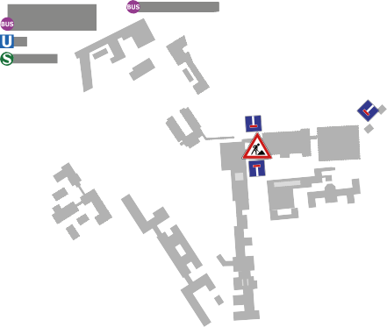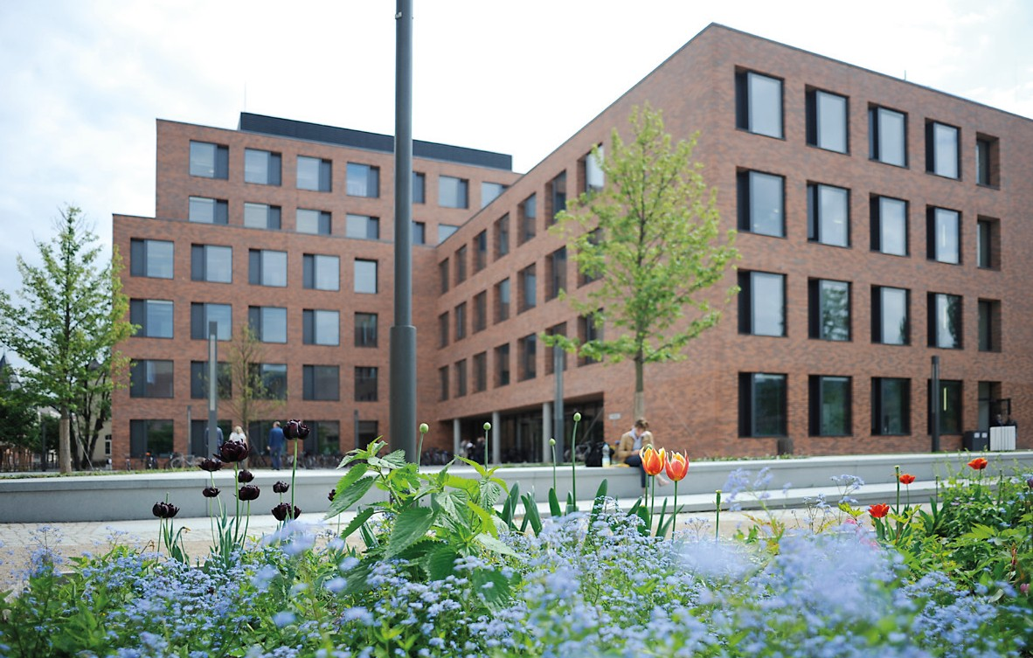

Name, First Name, Title Institution

Telephone | e-mail

Accommodation
We have reserved a contingent of rooms:
Adina Apartment Hotel Berlin Hauptbahnhof. E-mail: abhb@adina.eu
Tel. +49 30 2000 32580 | Fax +49 30 2000 32599
Nordic Hotel Berlin Mitte. E-mail: Berlin-Mitte@nordic-hotels.com
Tel. +49 30 203 956 100 | Fax +49 0431 8866 5177
For both hotels please mention the key word „Zuha“

1000 €
Day 1+2 (19.-20.02.2015): Campus Charité Mitte Auditorium, Charité Cross Over, Virchowweg 6, 10117 Berlin Day 3 (21.02.2015): Medizinisches Kompetenzzentrum (Medizin im Grünen) near Bad Saarow – transfer included
Course directors
Mahmoud Ismail, Diego Gonzalez Rivas

Faculty
María Delgado Roel Consultant surgeon. Coruña Hospital. Spain Ricardo Fernández Prado Consultant surgeon. Coruña Hospital. Spain Diego Gonzalez Rivas Consultant surgeon. Coruña Hospital. Spain Mahmoud Ismail Consultant surgeon. Charité. Berlin
Layout: SG | Zentrale Mediendienstleistungen | Charité – Universitätsmedizin Berlin | Folder_VATS_Course_2015.indd
Antonio Martin-Ucar Consultant surgeon. Nottingham. UK
Nicolas Moreno Mata Chief. Thoracic surgery department. Hospital Uni- versitario Virgen del Rocio. Sevilla. Spain
Jens Neudecker Consultant surgeon. Charité. Berlin
Vadim Pischik Chief. Thoracic Surgery department. Saint Petersbourg state University hospital. Russia
Gaetano Rocco Chief. Thoracic surgery department. National Cancer Institute. Italy
Jens C. Rückert Head of Thoracic surgery. Charité. Berlin
Marco Scarci Consultant surgeon. Papworth Hospital. Cambridge. UK Alan Sihoe Clinical Associate Professor. The University of Hong Kong Chief of Thoracic Surgery. HKU Shenzhen Hospital. China
Marc Swierzy Surgeon. Charité. Berlin

For questions please contact
R. Mette, M. Schmitt
Charité – Universitätsmedizin Berlin
Tel. +49 30 450 622 132 | Fax +49 30 450 522 929
E-mail: thoraxchiurgie@charite.de

2nd International Uniportal VATS Course
– Live Surgery

19 – 21 Feb 2015 | Berlin
Uniportal VATS for Lung Cancer

